

REAL ESTATE MANAGEMENT SYSTEM
Admin-Only Product Blueprint, Visual Designs and End-to-End Workflows
Bakaal Real Estate Management System provides a secure workspace for managing property records, units, agreements, invoices, payments, operating expenses, staff, maintenance, notices and reports.
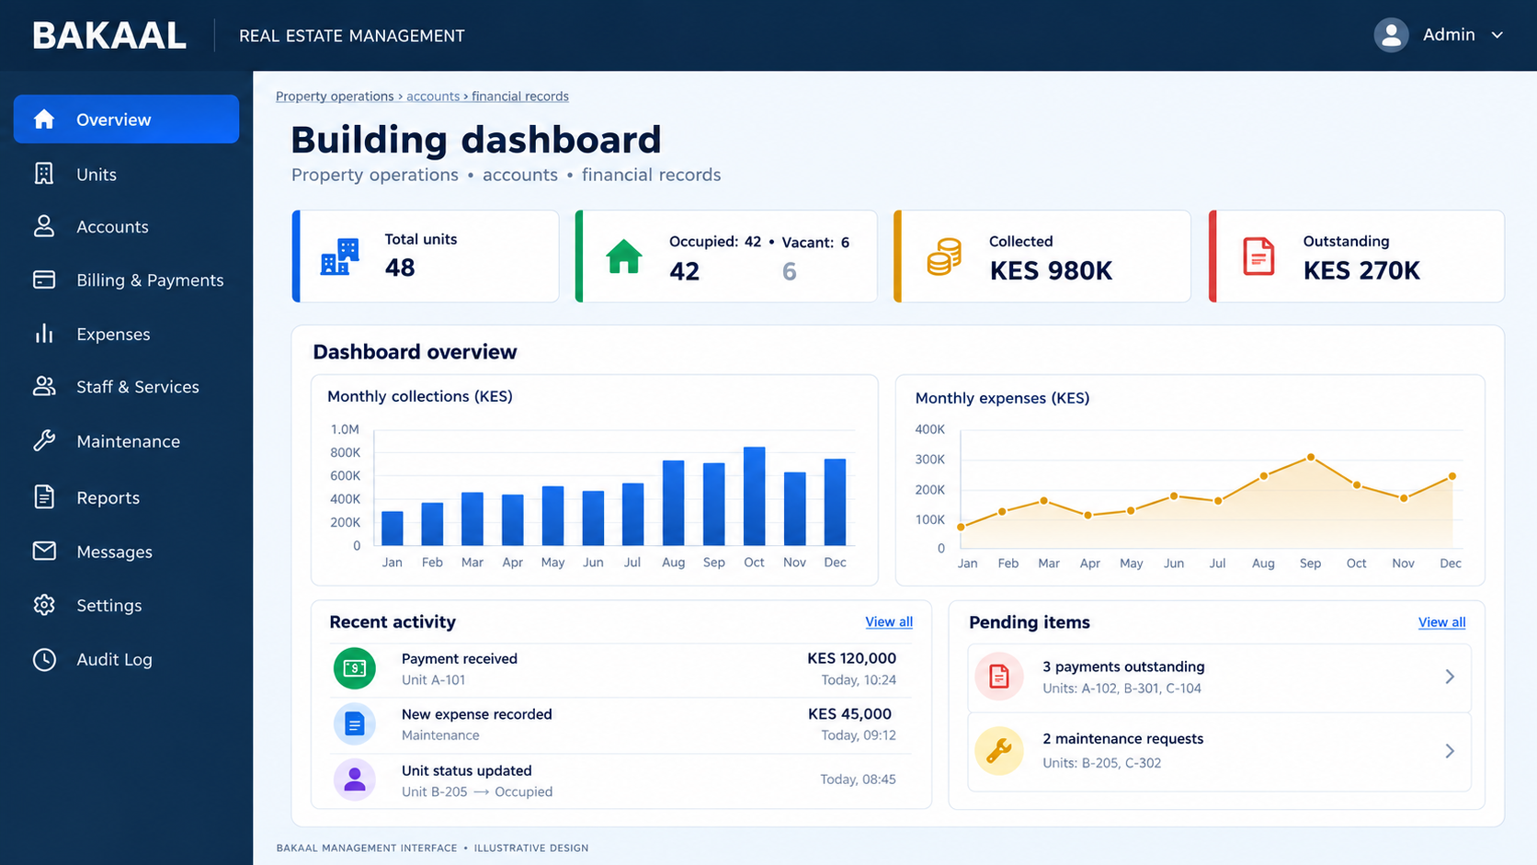

1. Scope and account types
Account categories identify the relationship to a unit and determine the applicable agreements, charges and recordkeeping rules.
Record type | Staff records | Billing behaviour
Rent-paying tenant | Person, unit, rental agreement, rent amount, dates and fee policy | Rent + approved shared/service charges
Purchased unit owner | Owner, unit ownership record, purchase date/documents and shared-charge policy | No rent by default; only approved applicable shared expenses
Purchased unit managed by Bakaal | Owner, purchased unit, ownership documents, management agreement, management fee policy, and applicable service/shared-charge policy | No rent by default. Charge agreed management fees and approved applicable shared expenses according to the management agreement.
Vacant unit | Unit status and readiness notes | No invoice without a valid agreement
Former occupant/owner | Closed dated history | Retain history; stop future billing after effective end date

2. Internal staff roles
Role | Access
System administrator / building owner | All modules, configuration, staff accounts, permissions and audit log
Building manager | Units, accounts, occupancy, billing review, maintenance, notices and operational reports
Finance officer | Invoices, payment verification, receipts, expenses and finance reports
Operations staff | Assigned tasks and expense submissions; restricted salary/finance access
Read-only auditor | Approved reports and audit trail; no editing

All account records, billing activities and communications are managed through the authorised management workspace.

3. Admin login
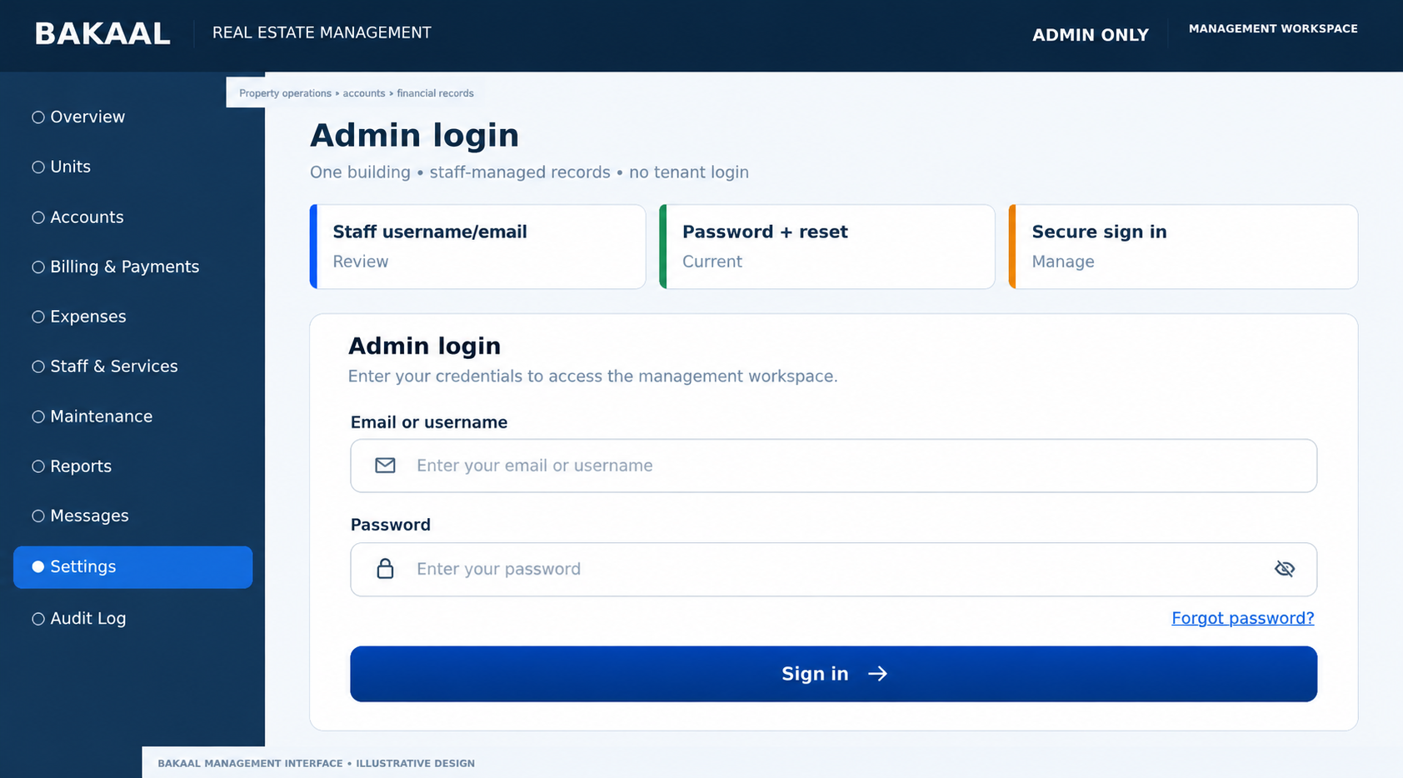
Design 1: unique admin-side screen concept. Sample data is illustrative.

Briefing / purpose
Secure entry for authorised staff only.

Screen elements
- Staff username/email
- Password + reset
- Secure sign in

Workflow: start to finish
- Staff enters credentials
- Server validates staff account and role
- Open authorised admin workspace

Technical and business rules
- Secure authentication and controlled access
- Secure cookies, password hashing and rate limits

Acceptance check
Unauthorised users cannot access the application or APIs.

4. Building dashboard
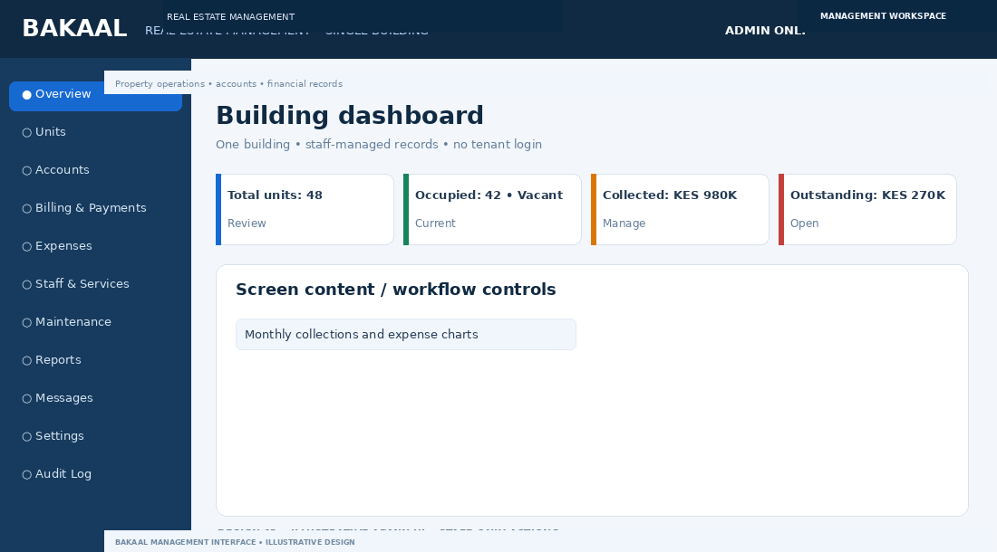
Design 2: unique admin-side screen concept. Sample data is illustrative.

Briefing / purpose
Single command centre for occupancy and finances.

Screen elements
- Total units: 48
- Occupied: 42 • Vacant: 6
- Collected: KES 980K
- Outstanding: KES 270K
- Monthly collections and expense charts

Workflow: start to finish
- Staff signs in
- Dashboard aggregates source records
- Click KPI to open the relevant list

Technical and business rules
- Document KPI formulas
- Totals reconcile with reports

Acceptance check
Dashboard totals match detail ledgers.

5. Unit register
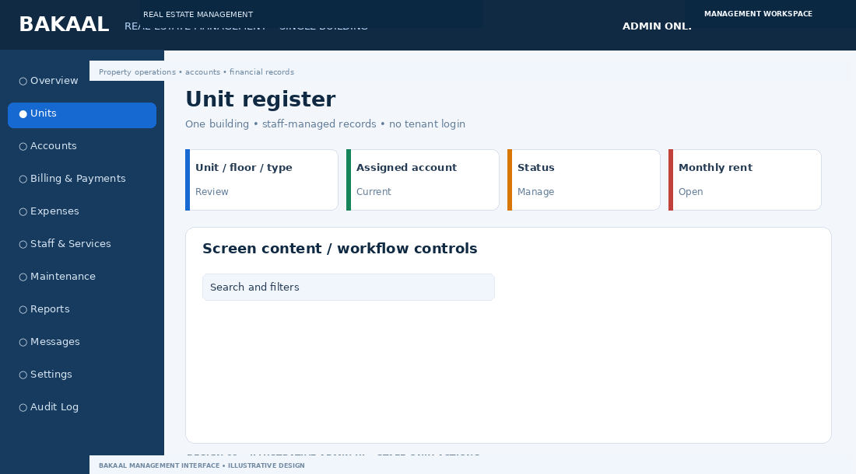
Design 3: unique admin-side screen concept. Sample data is illustrative.

Briefing / purpose
Track every unit, its details, occupancy status and history.

Screen elements
- Unit / floor / type
- Assigned account
- Status
- Monthly rent
- Search and filters

Workflow: start to finish
- Create unit inventory
- Assign rental agreement or owner record
- Validate conflicting active assignments

Technical and business rules
- Unique unit number
- Keep dated occupancy history

Acceptance check
No conflicting active unit assignment.

6. Unit detail and history
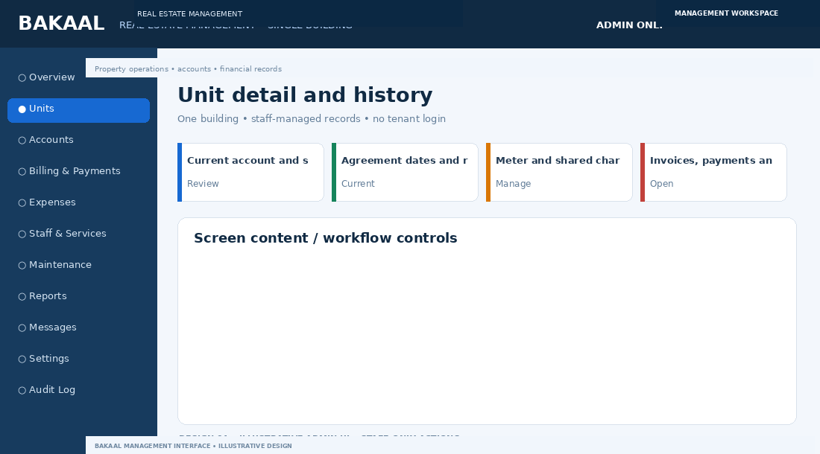
Design 4: unique admin-side screen concept. Sample data is illustrative.

Briefing / purpose
View a unit’s agreements, charges, maintenance and history.

Screen elements
- Current account and status
- Agreement dates and rent terms
- Meter and shared charge policy
- Invoices, payments and work orders

Workflow: start to finish
- Open unit from register
- Review or edit authorised fields
- Write changes to audit history

Technical and business rules
- Future changes must not rewrite issued invoices

Acceptance check
Former occupants and past transactions remain available.

7. Central account register
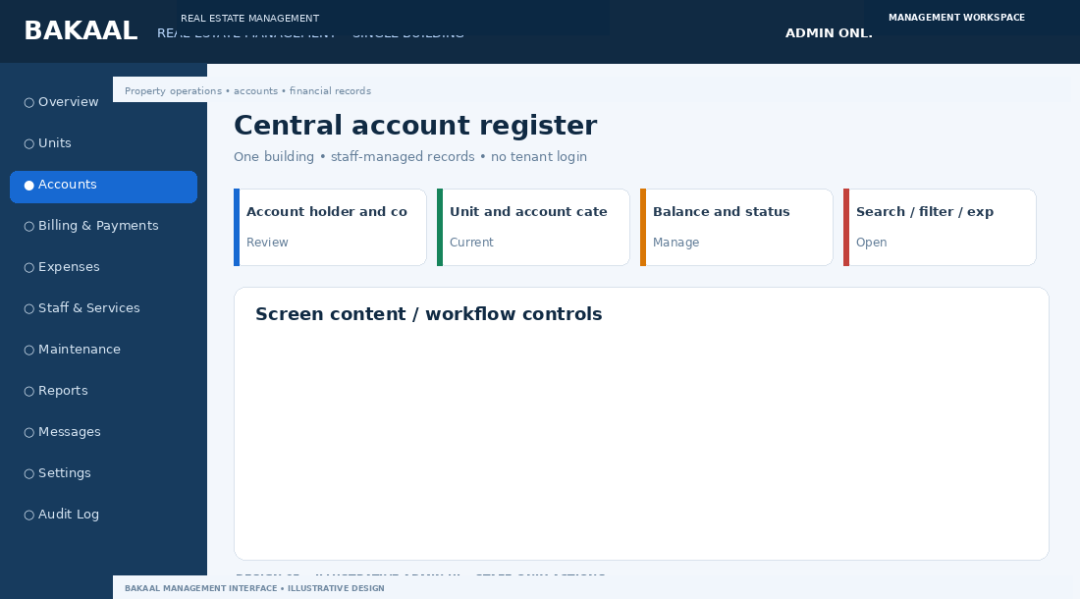
Design 5: unique admin-side screen concept. Sample data is illustrative.

Briefing / purpose
Manage every renter and owner record internally.

Screen elements
- Account holder and contact
- Unit and account category
- Balance and status
- Search / filter / export

Workflow: start to finish
- Search or create person record
- Classify renter or purchased-unit owner
- Open complete account history

Technical and business rules
- Account category is not a login role
- Protect sensitive documents

Acceptance check
Account classification determines billing rules and recordkeeping requirements.

8. Create account and assign unit
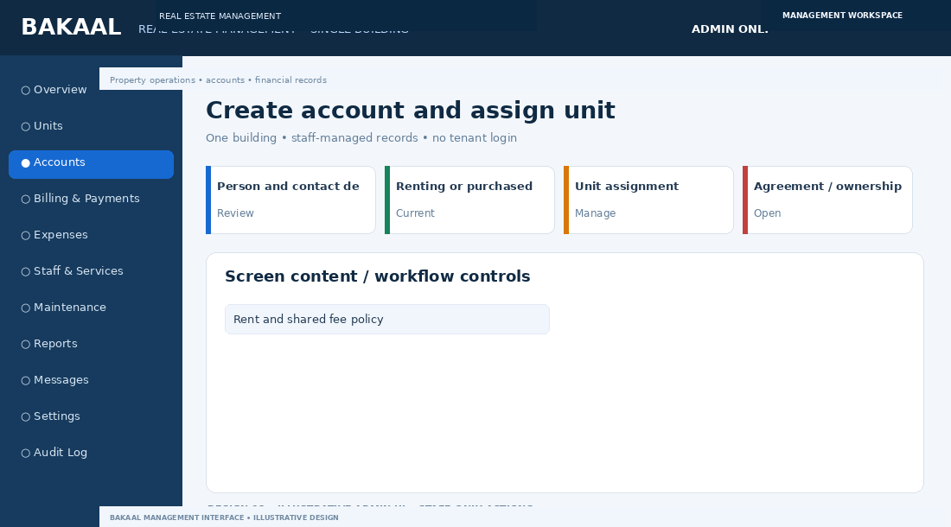
Design 6: unique admin-side screen concept. Sample data is illustrative.

Briefing / purpose
Register a renter or owner and configure the correct rules.

Screen elements
- Person and contact details
- Renting or purchased owner
- Unit assignment
- Agreement / ownership dates
- Rent and shared fee policy

Workflow: start to finish
- Enter person details
- Choose account type
- Assign unit and dates
- Validate and save

Technical and business rules
- Rent requires active rental agreement
- Owner record requires ownership evidence

Acceptance check
Account type and unit status are consistent.

9. Purchased unit owner
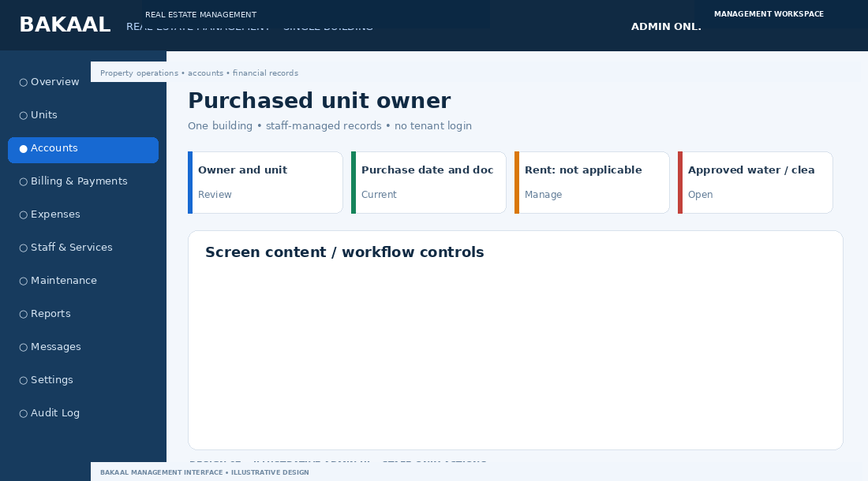
Design 7: unique admin-side screen concept. Sample data is illustrative.

Briefing / purpose
Record a sold unit and its owner’s shared expenses.

Screen elements
- Owner and unit
- Purchase date and documents
- Rent: not applicable by default
- Approved water / cleaning / garbage charges

Workflow: start to finish
- Mark unit purchased/owner-occupied
- Attach ownership evidence
- Set applicable shared charge policy

Technical and business rules
- No rent by default
- Preserve previous owner history

Acceptance check
Owner account generates no rent line by default.

10. Monthly billing run
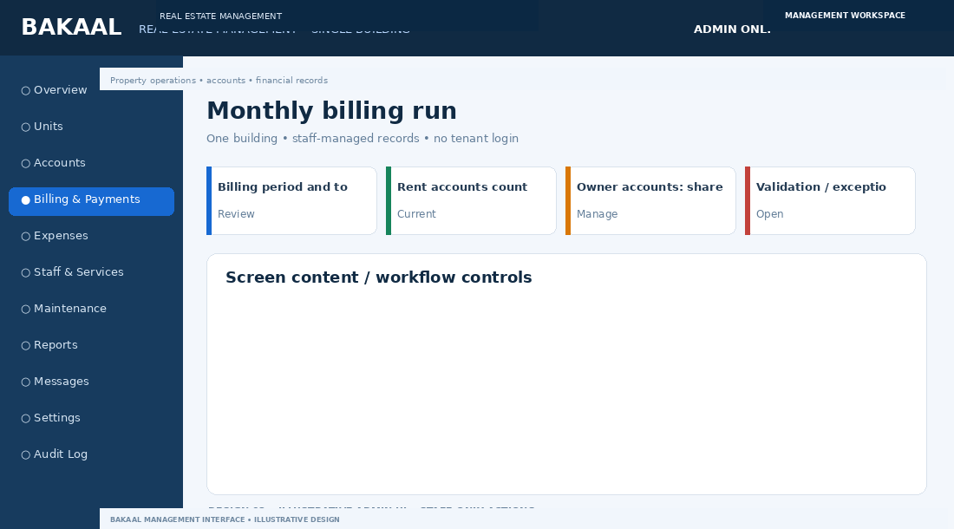
Design 8: unique admin-side screen concept. Sample data is illustrative.

Briefing / purpose
Generate accurate monthly invoices.

Screen elements
- Billing period and totals
- Rent accounts count
- Owner accounts: shared fees only
- Validation / exception list

Workflow: start to finish
- Run billing job
- Apply active agreements and fee rules
- Check duplicates and exceptions
- Preview and issue invoices

Technical and business rules
- Idempotent billing runs
- Snapshot rates and rule references

Acceptance check
Retrying the same period does not duplicate invoices.

11. Invoice ledger and arrears
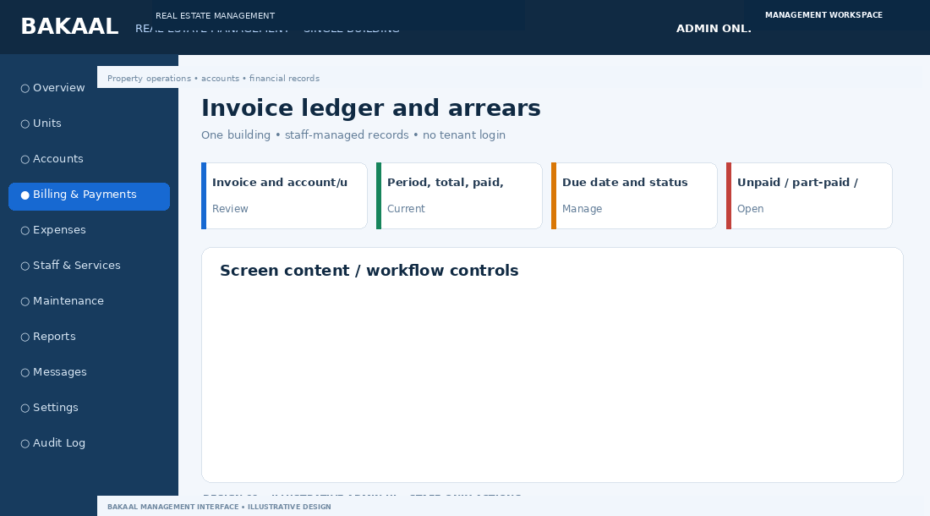
Design 9: unique admin-side screen concept. Sample data is illustrative.

Briefing / purpose
Track charges, paid amounts and outstanding balances.

Screen elements
- Invoice and account/unit
- Period, total, paid, balance
- Due date and status
- Unpaid / part-paid / overdue filters

Workflow: start to finish
- Open invoice
- Review line items and allocations
- Correct via credit or reversal

Technical and business rules
- Never silently edit posted financial history

Acceptance check
Invoice balance matches payment allocations.

12. Payment verification
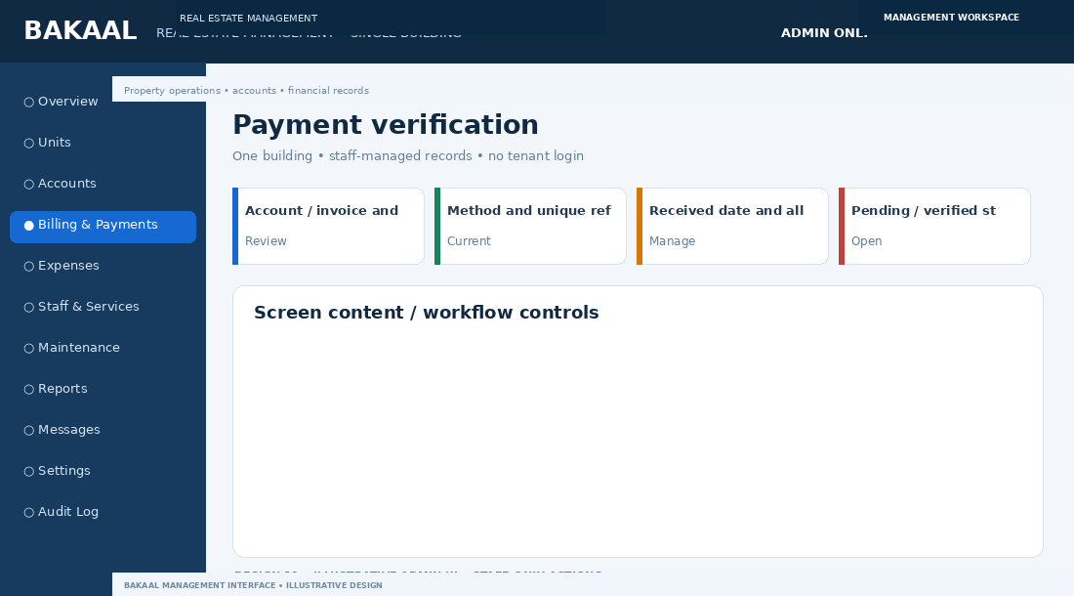
Design 10: unique admin-side screen concept. Sample data is illustrative.

Briefing / purpose
Record and verify M-Pesa, bank and cash payments.

Screen elements
- Account / invoice and amount
- Method and unique reference
- Received date and allocation
- Pending / verified status

Workflow: start to finish
- Record pending payment
- Verify provider/bank/cash evidence
- Allocate to invoice
- Confirm and issue receipt

Technical and business rules
- Provider callbacks idempotent
- Uploaded proof alone is not confirmation

Acceptance check
Duplicate callback cannot create duplicate receipt.

13. Building expenses register
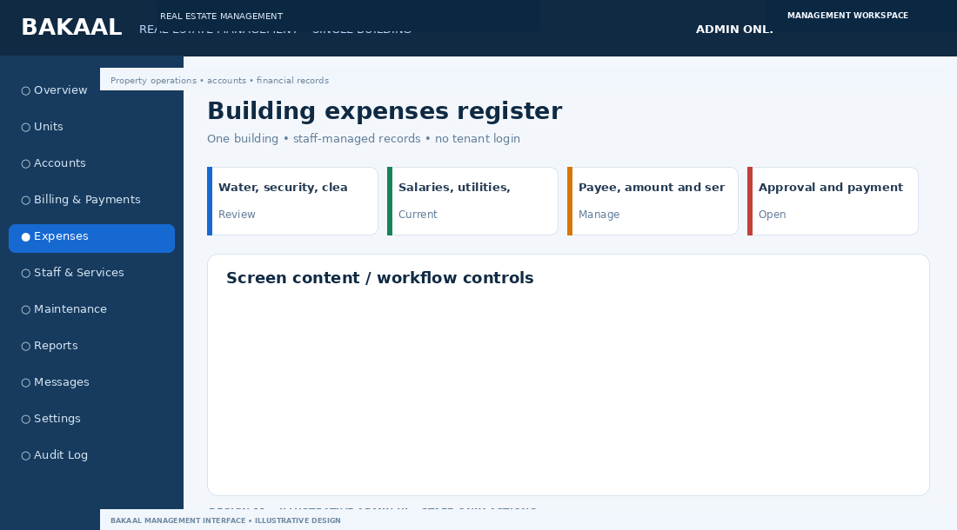
Design 11: unique admin-side screen concept. Sample data is illustrative.

Briefing / purpose
Track all outgoing costs for the building.

Screen elements
- Water, security, cleaning, garbage
- Salaries, utilities, repairs
- Payee, amount and service period
- Approval and payment status

Workflow: start to finish
- Staff submits expense
- Approver reviews
- Finance records payment
- Posted expense appears in reports

Technical and business rules
- Expense outflow separate from charge income

Acceptance check
Expense entry does not automatically bill occupants.

14. Expense entry and approvals
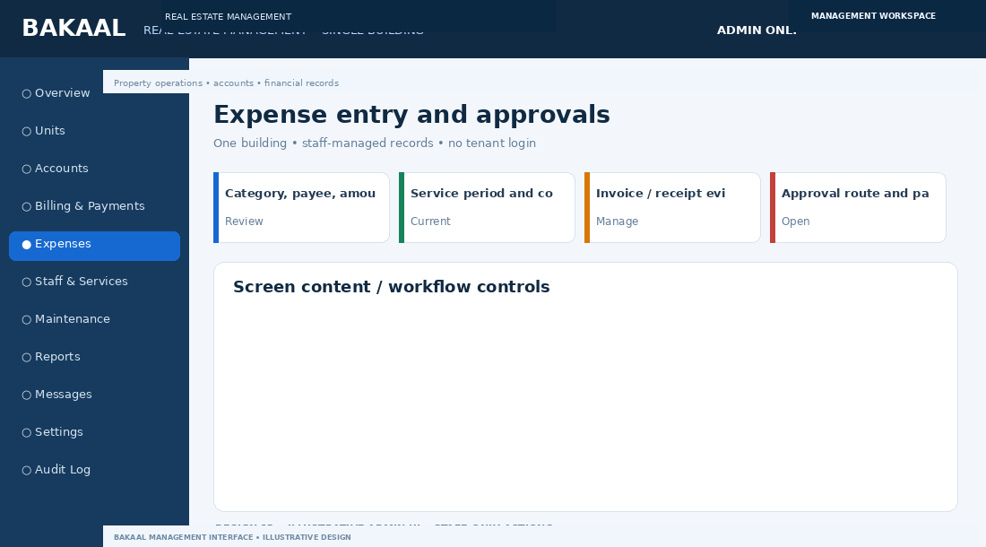
Design 12: unique admin-side screen concept. Sample data is illustrative.

Briefing / purpose
Capture evidence and enforce spending controls.

Screen elements
- Category, payee, amount
- Service period and cost centre
- Invoice / receipt evidence
- Approval route and payment method

Workflow: start to finish
- Save draft or submit
- Approver approves/rejects with reason
- Finance marks paid after verification

Technical and business rules
- Role and threshold checks
- Log all decisions

Acceptance check
Unauthorised staff cannot approve restricted expenses.

15. Staff, salaries and services
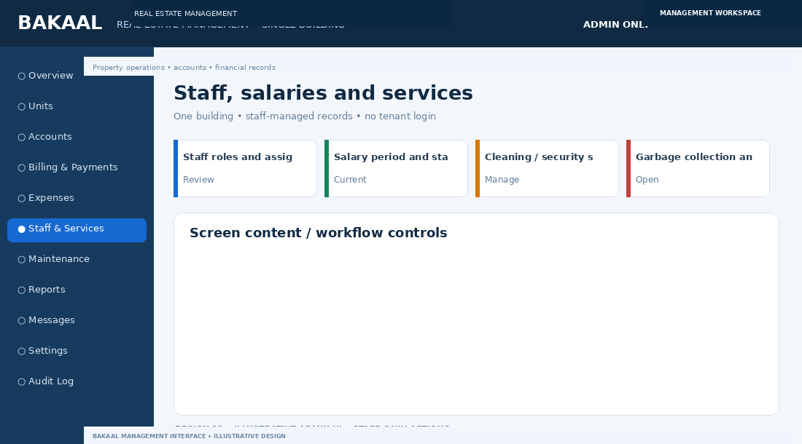
Design 13: unique admin-side screen concept. Sample data is illustrative.

Briefing / purpose
Manage cleaners, guards, caretakers and recurring duties.

Screen elements
- Staff roles and assignments
- Salary period and status
- Cleaning / security schedules
- Garbage collection and inspections

Workflow: start to finish
- Create staff record
- Assign schedules and tasks
- Record completion
- Review salary expense and exceptions

Technical and business rules
- Restrict salary access
- Separate task completion from salary payment

Acceptance check
Operations staff cannot view unrestricted salary details.

16. Maintenance and work orders
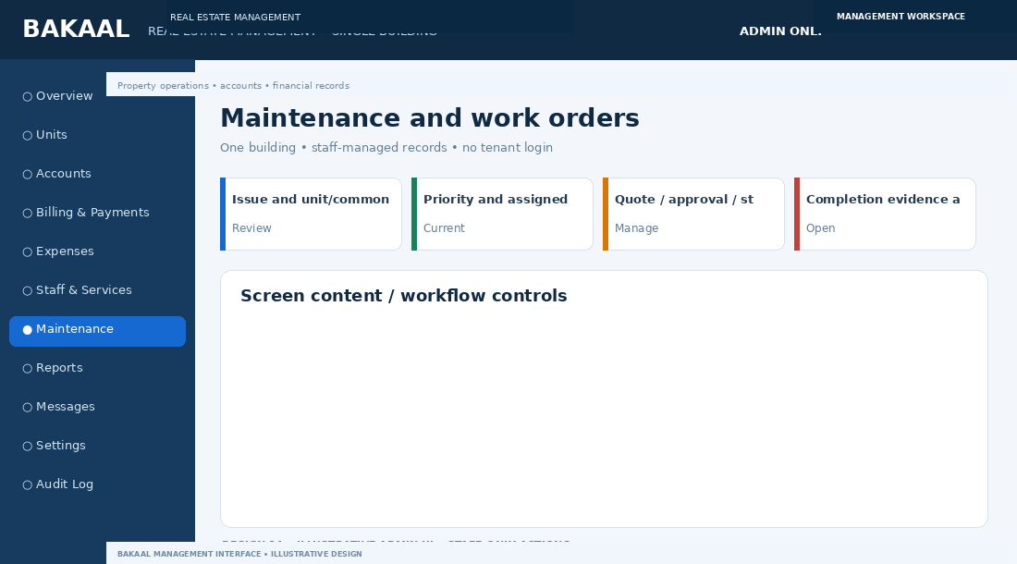
Design 14: unique admin-side screen concept. Sample data is illustrative.

Briefing / purpose
Manage repairs for units and shared areas.

Screen elements
- Issue and unit/common area
- Priority and assigned vendor
- Quote / approval / status
- Completion evidence and cost

Workflow: start to finish
- Create work order from inspection or report
- Assign worker/vendor
- Approve quote if needed
- Record completion and expense link

Technical and business rules
- Staff record issues received by phone, email or in person.

Acceptance check
Closed work order has outcome and cost treatment.

17. Reports and analytics
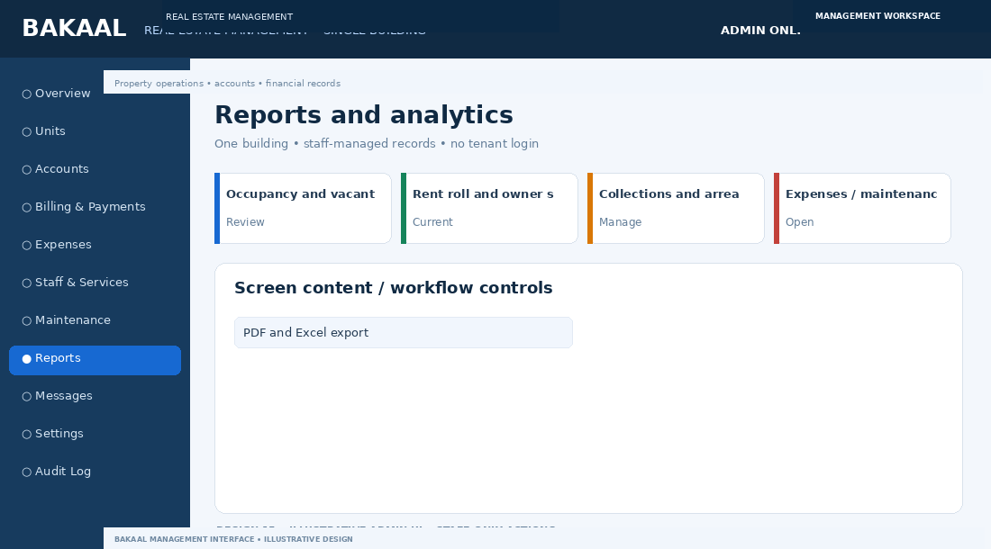
Design 15: unique admin-side screen concept. Sample data is illustrative.

Briefing / purpose
Produce management-ready operational and financial reports.

Screen elements
- Occupancy and vacant units
- Rent roll and owner shared charges
- Collections and arrears ageing
- Expenses / maintenance / staff
- PDF and Excel export

Workflow: start to finish
- Choose report and period
- Generate from source records
- Review exceptions and export

Technical and business rules
- Opening + charges − payments − credits = closing
- Respect role permissions

Acceptance check
Report totals reconcile to source records.

18. Notices and message log
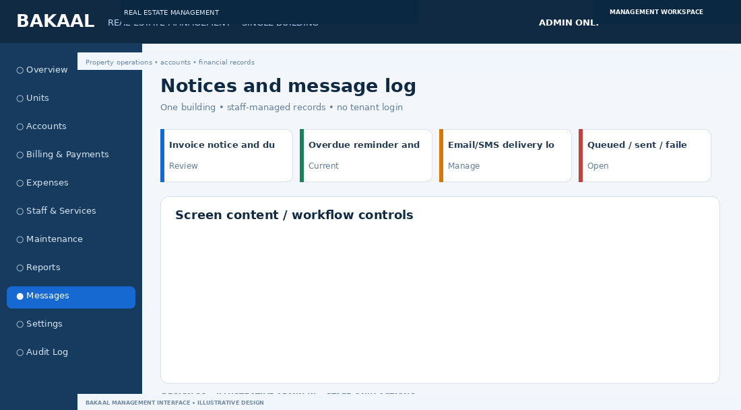
Design 16: unique admin-side screen concept. Sample data is illustrative.

Briefing / purpose
Send reminders without giving recipients system access.

Screen elements
- Invoice notice and due reminder
- Overdue reminder and receipt
- Email/SMS delivery log
- Queued / sent / failed / suppressed

Workflow: start to finish
- Event queues message
- Worker checks eligibility and sends
- Recheck balance before overdue reminder
- Log result and retries

Technical and business rules
- Messages provide relevant notices, due dates and payment references.
- Suppress reminders after payment

Acceptance check
Paid accounts are excluded from overdue reminders at dispatch.

19. Settings and permissions
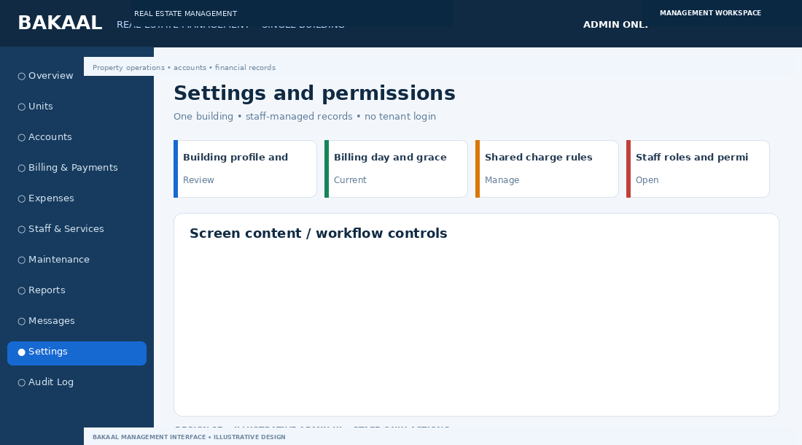
Design 17: unique admin-side screen concept. Sample data is illustrative.

Briefing / purpose
Configure building rules and staff access.

Screen elements
- Building profile and currency
- Billing day and grace period
- Shared charge rules
- Staff roles and permissions

Workflow: start to finish
- Admin changes setting
- Validate and save with effective date
- Write audit event

Technical and business rules
- Least privilege
- Version rules that affect billing

Acceptance check
Operations role cannot edit finance settings.

20. Audit trail
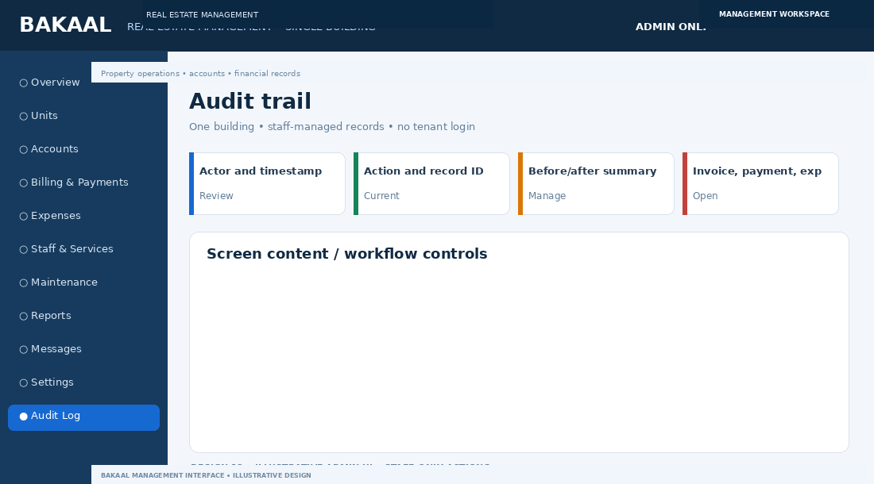
Design 18: unique admin-side screen concept. Sample data is illustrative.

Briefing / purpose
Trace important changes and financial actions.

Screen elements
- Actor and timestamp
- Action and record ID
- Before/after summary
- Invoice, payment, expense changes

Workflow: start to finish
- System logs material actions
- Authorised reviewer investigates
- Correct through reversal/adjustment

Technical and business rules
- Do not log passwords or secrets
- Protect audit history

Acceptance check
Material financial changes create audit events.

Technical architecture and database model
Recommended baseline: responsive internal web app, PostgreSQL, tested server-side business logic, private document storage, scheduled/background jobs and audit logging. A practical stack is Next.js + TypeScript, PostgreSQL + Prisma, secure staff sessions and a background queue for billing and notifications.
Entity | Purpose
Building | One record for the property
Unit | Unit number, floor, type, status, meters and history
StaffUser / Role / Permission | Only staff authenticate; role controls access
Person / AccountRecord | Renter, unit owner, former occupant and contact details; not login credentials
RentalAgreement / OwnershipRecord | Effective dates, rent terms or ownership evidence
ChargePolicy / ChargeRule | Shared fees, calculation/allocation and effective dates
Invoice / InvoiceLine | Itemised charges and issued line snapshots
Payment / PaymentAllocation / Receipt | Verified receipts and invoice allocations
Expense / ExpenseApproval | Operating cost, evidence, approval and payment history
Staff / ServiceTask | Staff assignments and recurring operations
MaintenanceTicket / WorkOrder | Repair lifecycle and linked costs
MessageLog / MessageTemplate | Automated and staff-triggered messages
AuditEvent | Trace of important changes and access

Suggested API groups
Area | Example | Control
Staff authentication | POST /api/auth/login | Active staff only
Units | GET/POST /api/units | Property scope
Accounts | POST /api/accounts | No public/tenant self-registration
Billing | POST /api/billing-runs | Idempotent generation
Payments | POST /api/payments; POST /api/webhooks/mpesa | Verify and deduplicate
Expenses | POST /api/expenses/:id/approve | Role and approval limits
Work orders | POST /api/work-orders | Staff-managed lifecycle
Reports | GET /api/reports/arrears | Permission-controlled exports

Critical financial rules
- Rent is billed only to accounts with an active rent-paying agreement.
- Purchased unit owners are not charged rent by default; only approved shared expenses apply.
- Operating expenses and occupant charge income are separate records.
- Payments must be verified before balances update; support partial allocations.
- Correct posted records with controlled reversals/credits, not silent deletion.
- Every report reconciles to the source ledger and respects staff permissions.

Recommended build order
- Confirm unit inventory, renter/owner definitions, shared expense rules, billing dates and staff roles.
- Build staff login, permissions, units and central accounts.
- Build agreements, charge policies, invoices and balances.
- Build payment verification, allocations, receipts and reconciliation.
- Build expenses, approvals, staff/salary controls and maintenance.
- Build notices, reports, exports and audit log.
- Pilot with sample records and reconcile a full billing period before sign-off.

Final requirement
The Bakaal Real Estate Management System brings property records, occupancy, agreements, rent and shared charges, payments, expenses, staff, maintenance, notices, reports and configuration into one secure management workspace.

Technical references
- Safaricom Daraja: https://developer.safaricom.co.ke/apis/GettingStarted
- Kenya ODPC: https://www.odpc.go.ke/guidelines-2/
- OWASP Authorization: https://cheatsheetseries.owasp.org/cheatsheets/Authorization_Cheat_Sheet.html
- OWASP Logging: https://cheatsheetseries.owasp.org/cheatsheets/Logging_Cheat_Sheet.html

